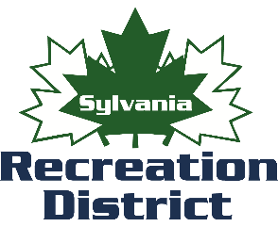

**Get up to the minute Sylvania Recreation athletic program cancelations, facility closures, and more.**

To receive **Fall Baseball/Softball** alerts text keyword “2025BASEBALLSOFTBALL” to 84483.

To receive **Cheerleading** alerts text keyword

“2025CHEERLEADING” to 84483.

To receive **Flag Football** alerts text keyword “2025FLAGFOOTBALL” to 84483.

To receive **Tackle Football** alerts text keyword “2025TACKLEFOOTBALL” to 84483.

To receive **Fall Soccer** alerts text keyword “2025FALLSOCCER” to 84483.

To receive **Adult Softball** alerts text keyword

“ADULTSOFTBALL2025” to 84483.

To receive **Senior Softball** alerts text keyword

“SENIORSOFTBALL2025” to 84483.